Participant Photo Guide for Profiles

“A photo is worth a thousand words.”

The participant profiles are an exciting new tool we are creating to tell the stories of our programs and the people they serve. As part of the profiles, we are requiring a minimum of two photos with every profile; a profile picture and an “action” shot of the participant at work.

Don’t worry the photos don’t need to be professional quality, a cellphone or tablet will work.

Here are examples of the two required photos.
Photo 1: Profile picture
Photo 2: Participant at work

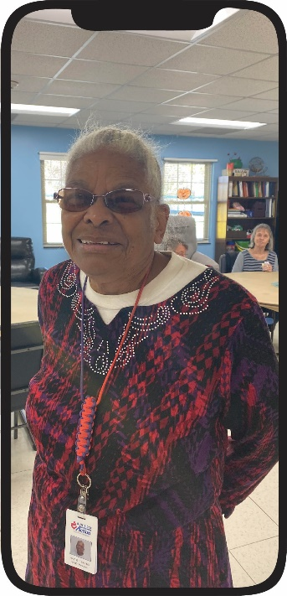
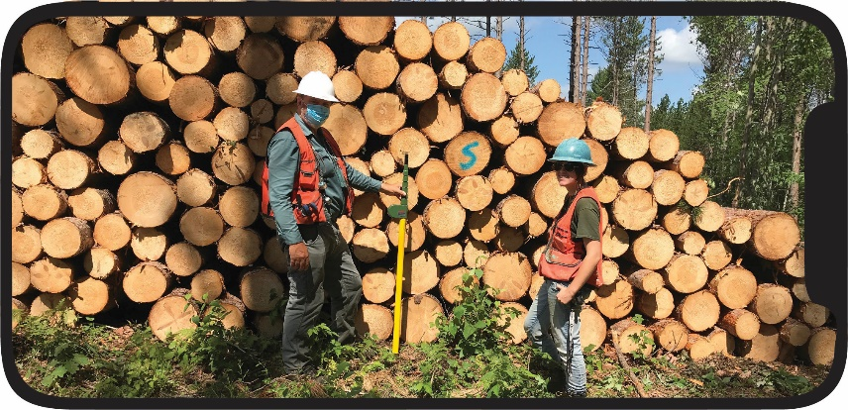

*Due to COVID restrictions on in-person activities photos of participants at work might not be possible. In such cases alternate photos can be shared.

Make sure to have the participant complete and sign the photo release form attached below.
~~~~~~~~~~~~~~~~~~~~~~~~~~~~~~~~~~~~~~~~~~~~~~~~~~~~~~~~~~~~~~~

Photo Release Consent Form

I hereby grant permission to the Center for Workforce Inclusion to use photographs and/or video of me in its communications related to the mission of authorize Center for Workforce Inclusion and/or the services it provides, including but not limited to blog posts, social posts, web updates, and news releases, without payment or other consideration. I understand and agree that all photos/videos will become the property of authorize Center for Workforce Inclusion and will not be returned.
I hereby irrevocably authorize Center for Workforce Inclusion the right to edit, alter, copy, exhibit, publish, or distribute these photos/videos for any lawful purpose. In addition, I waive any right to inspect or approve the finished product wherein my likeness appears. Additionally, I waive any right to royalties or other compensation arising or related to the use of the photo/video.
I hereby hold harmless, release, and forever discharge authorize Center for Workforce Inclusion from all claims, demands, and causes of action which I, my heirs, representatives, executors, administrators, or any other persons acting on my behalf or on behalf of my estate have or may have by reason of this authorization.
I HAVE READ AND UNDERSTAND THE ABOVE PHOTO/VIDEO RELEASE. I AFFIRM THAT I AM AT LEAST 18 YEARS OF AGE, OR, IF I AM UNDER 18 YEARS OF AGE, I HAVE OBTAINED THE REQUIRED CONSENT OF MY PARENTS/GUARDIANS AS EVIDENCED BY THEIR SIGNATURES BELOW. I ACCEPT:

Name: ________________________________________
Program Name: _________________________________
Address: ______________________________________________________
_______________________________________________________________
Phone: _______________________________________
Email Address: _____________________________________________

