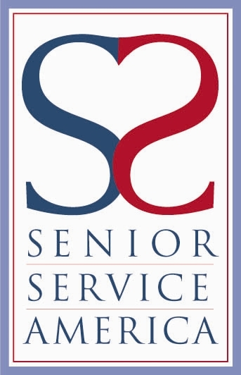Senior Service America

Your logo here

and

Your Project Name

proudly recognize

Insert Host Agency Name
as an

Outstanding Host Agency
for partnering with the Senior Community Service Employment Program and providing community service and job-skills training opportunities that enrich and transform the lives of older adults.

_________________________________________ ___________________________________
Signing Official Name Name, Project Director
Affiliation Project Name

