Urgent – Share your SCSEP Story

Dear Colleagues,
Many of you have told me how much SCSEP has helped you reconnect with the workforce and build new skills, and I’ve seen firsthand the difference it’s made. Now, I’m asking you to share your story with the people who need to hear it most: our local representatives.
Right now, Congress is making important decisions about which programs to support, and SCSEP is at risk of being left out simply because too few people understand its impact. Lawmakers need to hear directly from those who have benefited. This is a key moment to speak up and ensure they recognize how vital SCSEP is to older workers, families and local communities.
We’ve made it easy for you to take action in just a few minutes:
- A letter you can personalize or send as-is to our representatives
- A phone script to help you leave a message for each representative
We can only succeed in raising awareness if we act together and your story can make a real difference. When lawmakers hear directly from the people their decisions affect, it helps them understand why programs like SCSEP matter.
Thank you for being a powerful voice for older workers and for continuing to show what experience can do.

Locating Contact Information for Lawmakers
To find your local representatives, visit Congress.Gov and utilize the Contact Your Member feature in the right-side toolbox.

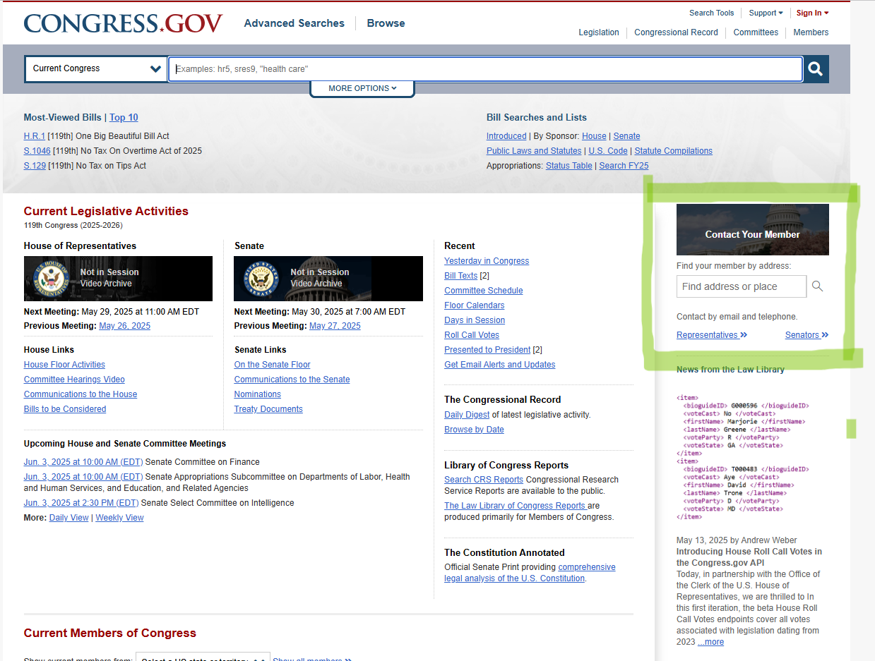

Customizable Email from Employed Job Seeker to Lawmakers
[Date]

The Honorable [First Name Last Name]
[Office Address]
United States House of Representatives / Senate
Washington, D.C. [ZIP Code]

Dear Representative/Senator [Last Name],
Thank you for your continued support of America’s older workers. I’m writing today not just as a constituent, but as someone who was desperate to get back into the workforce and couldn’t find the resources to help until I found the Senior Community Service Employment Program (SCSEP).
[I struggled for months to find a job. I felt discouraged and overlooked until SCSEP gave me a way forward.]
[I needed to return to the workforce after spending #years caring for [relationship type such as wife, parents, siblings, etc.] but my skills were outdated. SCSEP gave me a way forward.]
[I retired after # years working in [industry/field] but, like many older Americans, I had to return to the workforce to maintain my financial independence. My skills, however, were outdated until SCSEP gave me a way forward.]
The program’s hands-on, paid job training has helped me build the up-to-date skills employers are looking for, including all-important digital skills. Through SCSEP, I found employment and financial independence.
The program’s contributions reach far beyond my personal experience.
- SCSEP has a strong return on investment (ROI) – older Americans who exit for employment earn more in their first year than the annual SCSEP training
- SCSEP job seekers fuel the workforce – 7 in 10 older Americans who exit for employment remain on the job more than one year after leaving the program.
- SCSEP is an effective and fiscally smart investment of federal funds, representing only .003% of the Department of Labor’s annual budget.
As someone who has directly benefited from SCSEP, I can assure you that the program helps older Americans like me attain the skills to Make America Skilled Again. Thank you for your time and your service to our country.
Sincerely,
[Your Name]

Customizable Phone Script for Employed Job Seeker to Use with Lawmakers
Call the Capitol switchboard at (202) 224-3121 and ask to be connected to [Representative/Senator] [Last Name]’s Office.
Hi, my name is [Name], and I’m a constituent from [City]. I want to thank you for your ongoing support of older workers like me who have benefited from the Senior Community Service Employment Program, or SCSEP.
[I struggled for months to find a job. I felt discouraged and overlooked until SCSEP gave me a way forward.]
[I needed to return to the workforce after spending #years caring for [relationship type such as wife, parents, siblings, etc.] but my skills were outdated. SCSEP gave me a way forward.]
[I retired after # years working in [industry/field] but had to return to the workforce due to the rising cost of living / rising healthcare expenses. My skills were outdated until SCSEP gave me a way forward.]
SCSEP is the only federally funded program that offers paid, hands-on job training specifically for older Americans. Without SCSEP, I would still be discouraged and on the sidelines. But now, I’ve found employment and financial security through work.
SCSEP is more than just job training - it’s a smart investment in our nation’s workforce and the employers who hire them.
Thank you for your service to our country and seeing the value in programs like SCSEP that benefit the community that you and I both care about so much.

