Urgent – Help Educate Lawmakers About SCSEP
Dear Colleagues,
As Congress weighs its national priorities, it is more important than ever that we work together to ensure lawmakers understand the value that the Senior Community Service Employment Program (SCSEP) brings to our communities, our workforce and our economy.
We are launching a national outreach campaign to educate congressional representatives about how SCSEP equips older Americans with the skills needed to fill open roles and help close the country’s widening workforce gap.
We hope you will take a few moments to participate. When lawmakers hear directly from constituents, especially those whose organizations and communities have benefited from SCSEP, it makes a lasting impact.
Below are two ways for you to have your voice heard:
- A customizable letter that your organization can send to our representatives.
- A customizable phone script that you can use to leave a message for each of our representatives.
We can only succeed in raising awareness if we act together. Thank you for your continued commitment to helping older Americans return to work with purpose, dignity and skill.

Resources
- Locating Contact Information for Lawmakers
- Customizable Email from Host Agency to Lawmakers
- Customizable Phone Script for Host Agency to Use with Lawmakers

Locating Contact Information for Lawmakers
To find your local representatives, visit Congress.Gov and utilize the Contact Your Member feature in the right-side toolbox.

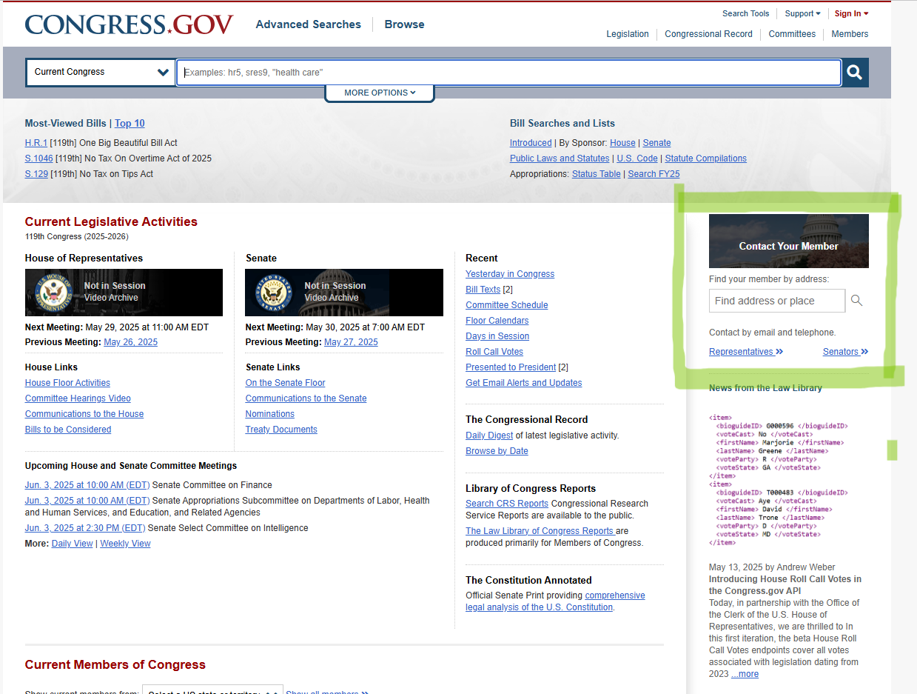

Customizable Email from Host Agency to Lawmakers

[Date]

The Honorable [First Name Last Name]
[Office Address]
United States House of Representatives / Senate
Washington, D.C. [ZIP Code]

Dear [Representative/Senator Last Name],
Thank you for your ongoing support of America’s older workers. As our nation faces a historic labor shortage, the experience, dedication, and resilience of older Americans are more valuable than ever. I am writing to share the critical role the Senior Community Service Employment Program (SCSEP) plays in addressing today’s workforce challenges and in advancing President Trump’s economic priorities, including the commitment to Make America Skilled Again.
By 2033, the United States is projected to face a shortfall of six million workers, with 74% of employers already reporting difficulty finding qualified candidates. At the same time, over a million older Americans are actively seeking employment, while millions more are ready and willing to work but have become discouraged after lengthy job searches. This is not a reflection of their ability, but rather a missed opportunity to harness a valuable and underutilized talent pool.
SCSEP bridges this gap. It is the only federally funded program specifically designed to provide older adults with the digital and industry-specific training they need to meet current labor market demands. Through SCSEP, participants gain hands-on, paid job training that prepares them for employment - helping employers fill vacancies while empowering older Americans to rejoin the workforce with confidence.
The program’s contributions are far-reaching.
- SCSEP has a strong return on investment (ROI) – older Americans who exit for employment earn more in their first year than the annual SCSEP training
- SCSEP job seekers fuel the workforce – 7 in 10 older Americans who exit for employment remain on the job more than one year after leaving the program.
- SCSEP is an effective and fiscally smart investment of federal funds, representing only .003% of the Department of Labor’s annual budget.
By helping experienced Americans gain the skills needed to reenter the workforce, SCSEP strengthens businesses, communities and the national economy. As we work to address the country’s growing workforce challenges, SCSEP offers a practical, effective solution that benefits employers and workers alike.
Thank you for your time and your service to our country.
Sincerely,
[Your Name]
[Organization]

Customizable Phone Script for Host Agency to Use with Lawmakers

Call the Capitol switchboard at (202) 224-3121 and ask to be connected to [Representative/Senator] [Last Name]’s Office.

Hi, my name is [Name], and I’m calling from [Organization]. I’m a constituent from [City], and I want to thank you for your ongoing support of older workers and the employers, like me, who are proud to hire them. I’d especially like to highlight the importance of the Senior Community Service Employment Program, or SCSEP. It’s the only federally funded program that offers paid, hands-on job training specifically for older Americans. Without SCSEP, we wouldn’t have the workforce we need to deliver [description of your services]. And many older Americans who are eager to work would remain discouraged and on the sidelines. SCSEP is more than just job training - it’s a smart investment in our local economy and in Making America Skilled Again.
Thank you for your service to our country and seeing the value in programs like SCSEP that benefit the community that you and I both care about so much.

